# Level-up CSP Technical Training – Power Platform Facilitator Guide

**Create a Holidays List Plugin**

|  |  |
| --- | --- |
| Description | A hands-on experience to inspire users to use Copilot Studio to develop a Holiday List Plugin. |
| Prerequisites | To get the most out of this training we recommend you have an Admin Tenant ID and Password and trial access to Microsoft Copilot Studio. If you do not have a tenant, to acquire Microsoft Admin trial tenant, go to [Microsoft 365](https://www.microsoft.com/en-us/microsoft-365/enterprise/e3?activetab=pivot:overviewtab) |
| Audience | Microsoft partners will deliver this workshop to CSP customers, who have multiple employees in their company, have a Microsoft Power Apps for Developer and Microsoft Power Automate license, and have minimal Copilot Studio experience. |
| Duration | 20 minutes |
| Publication date | September 2024 |

This document is provided “as-is”. Information and views expressed in this document, including URL and other Internet Web site references, may change without notice. You bear the risk of using it.

This document does not provide you with any legal rights to any intellectual property in any Microsoft product. You may copy and use this document for your internal reference purposes.

© 2024 Microsoft. All rights reserved.

Contents

Level-up CSP Technical Training – Power Platform Facilitator Guide 1

**Objective and Scenario** 2

**Objective** 2

**Solution focus area** 2

**Personas** 2

Exercise 1: Create a Conversational action 3

Exercise 2: Publishing your conversational action to Microsoft Copilot 13

**Objective and Scenario**

## **Objective**

Develop a conversational action that can be published as a Plugin to enable interaction within a cross-organizational group.

## **Solution focus area**

Contoso Corp, a leading IT solutions provider, is at the forefront of innovation, harnessing the power of generative AI to drive business efficiencies and enhance customer experiences. In 2023, Contoso has successfully developed a suite of out-of-the-box experiences that allow users to engage seamlessly with a wealth of content and resources across an organization, all powered by Microsoft Copilot Studio.

Now, Contoso wants to create a solution that facilitates interaction among cross-organizational groups. Contoso wants to demonstrate this solution to its customers to showcase the transformative potential of generative AI in real-world applications.

Based on the above requirements, you have decided to develop a solution that involves creating a conversational action using Microsoft Copilot Studio, which will be published as a Copilot Plugin. This initiative aims to enhance the value that customers derive from Copilot for M365, providing them with a more interactive and efficient experience.

The Plugins will be available in the Microsoft Copilot in production, if the organization has valid license for the same.

## **Personas**

* **Mark Brown** – Project lead
* **David Flores** – Copilot developer
* **Jane Miller** – Copilot tester

These personas will participate in the following sequential scenarios:

* Mark Brown, the Project Lead at Contoso Corp, provides David Flores with an overview of the tools and processes involved in creating a conversational action using Microsoft Copilot Studio and publishing it. Mark tasks David with creating a conversational action focused on holidays for the year 2024.
* David successfully creates a conversational action and publishes it.
* Once the conversational action is complete, David asks Mark for approval of the Plugin, which would allow it to be integrated into the organization's M365 Chat experiences. Mark promptly reviews the Plugin and, upon approval, enlists Jane Miller to conduct thorough testing.
* Jane interacts with the Plugin, provides valuable feedback and confirms its functionality. After successfully validating the Plugin, Mark Brown officially hands over the solution to the team. This milestone enables them to demonstrate the new conversational action to customers, enhancing their engagement and service offerings.

**Note:** The steps, after the action is published can be performed only if the organization holds a valid Copilot license with Admin rights for Mark to approve it from the admin center followed by the testing by Jane.

# Exercise 1: Create a Conversational action

**Objective**:

In this exercise, we will sign in for the Copilot Studio trial license, and then create a conversational action which will help to retrieve the list of holidays for the year 2024.

1. Login to **https://copilotstudio.microsoft.com/** using your tenant credentials
2. In the **Welcome to Copilot Studio** popup, leave the **country/region** as the default value and select **Start free trial**.

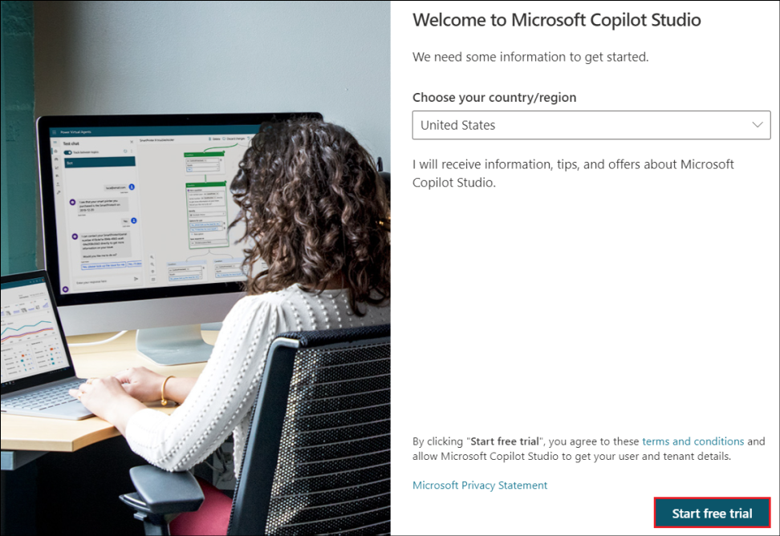

1. Select **Environments** on the top right and select **Dev One** from it.

**Note:** If you are not able to find the Dev One environment, follow these steps to create a developer environment.

* + Login to <https://admin.powerplatform.microsoft.com/>.
  + Select **Environments** from the left navigation pane and click on **+ New.**

* + In the New environment window that opens, fill in the below details and click on **Next**.

|  |  |
| --- | --- |
| **Property** | **Value** |
| Name | Dev env |
| Region | United States - Default |
| Type | Developer |

* + In the **Add Dataverse** window, accept the defaults and click on **Save**.

* + The newly created environment gets listed in the admin center with its status in the Environments pane.
  + Once the **status** is **ready**, switch back to the copilot studio page that we opened already.

* + Select the created environment (Dev env) in the Copilot Studio.

1. Select **Copilots** from the left pane.

1. Select **Copilot for Microsoft 365**.

1. Select **Actions** from the top menu.

1. Select **+ Add an action**.

1. Select **Conversational** in the **New action** pane.

1. Type in the name for the action as **Holiday List**. Select **Create**.

1. Once ready, the created action opens in Authoring canvas. Select **Topics**.

1. Name the topic as **Holidaylisttopic**.

1. In the Trigger node’s description, provide a clear description of how the conversational plugin can help the user and what it can do. Let this topic help the user to find the list of holidays in the year 2024.

Type **This plugin helps to retrieve the list of holidays for the year 2024.** in the Trigger node’s description.

This description has functional purpose and is used by Microsoft Copilot to determine whether to invoke your plugin or not.

1. Add a message node below the Trigger node.

1. Paste the below details to populate the message node with the **list of holidays**.
   * New Year's Day - January 1
   * Martin Luther King, Jr.'s Birthday (Third Monday of January) - January 15, 2024
   * Washington's Birthday or Presidents' Day (third Monday of February) - February 19
   * Memorial Day (last Monday of May) - May 27
   * Juneteenth Day - June 19
   * Independence Day - July 4
   * Labor Day (first Monday of September) - September 2
   * Columbus Day (Second Monday of October) - October 14
   * Veterans Day or Veterans Day - November 11
   * Thanksgiving Day (fourth Thursday of November): November 28
   * Christmas Day - December 25

1. Click on **Save** to save the action.

**Conclusion**:

In this exercise, we have designed a conversational action and explained in the topic description about when this specific action needs to be invoked. Based on this, the action will be invoked when someone needs information regarding the list of holidays for the year 2024.

# Exercise 2: Publishing your conversational action to Microsoft Copilot

**Objective:**

The objective of this exercise is to publish the action that we created in the previous exercise.

1. Publishing your conversational plugin creates a new plugin in the Dataverse registry for your Tenant. Once available there, your tenant admin needs to approve your plugin to be available to users in the Microsoft Copilot plugins catalog.
2. Click on **Publish**.

1. Select **Publish.**

1. Select **Publish** on **Publish latest content** dialog.

1. The publish status is shown on the screen.

**Note:** The publishing should be completed quickly. The actual availability in the Microsoft Admin Center will take a few minutes.

**Important :** For the plugin to get it listed in the admin center, the company will have to hold a valid Copilot license.

1. Your Admin can find the published plugin under **Integrated app** in the Microsoft Admin Center under **Settings**.
2. The Administrator has to login to the Microsoft Admin Center at **https://admin.microsoft.com/**
3. Click on **Show all** from the left pane to get a visibility of all the options.

1. Select **Integrated apps** under **Settings**.

1. The plugins sent for approval will get listed under the **Requested apps** tab. The admin can either approve or reject it.

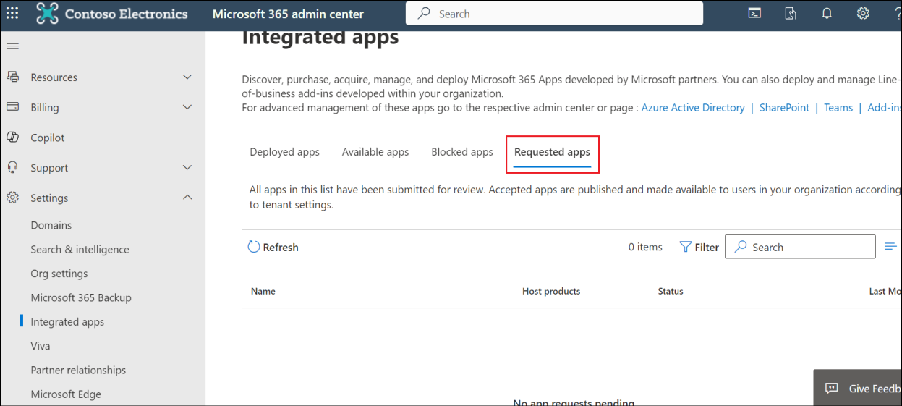

1. Once your Tenant admin approves the plugin, it should appear in the user's list of plugins in their Microsoft Copilot UI. It can be used by the user from there.

**Conclusion:**

In this exercise, we have learnt to publish the action and how it can be approved by the admin after which it will appear as a plugin in the Microsoft Copilot.

**Lab Conclusion:**

In this lab, we have learnt how to create a conversational action and to publish it.